SAMREEN RIAZ

56329

OOP LAB (SE-2)

MAAM NAVEERA

TASK 1:

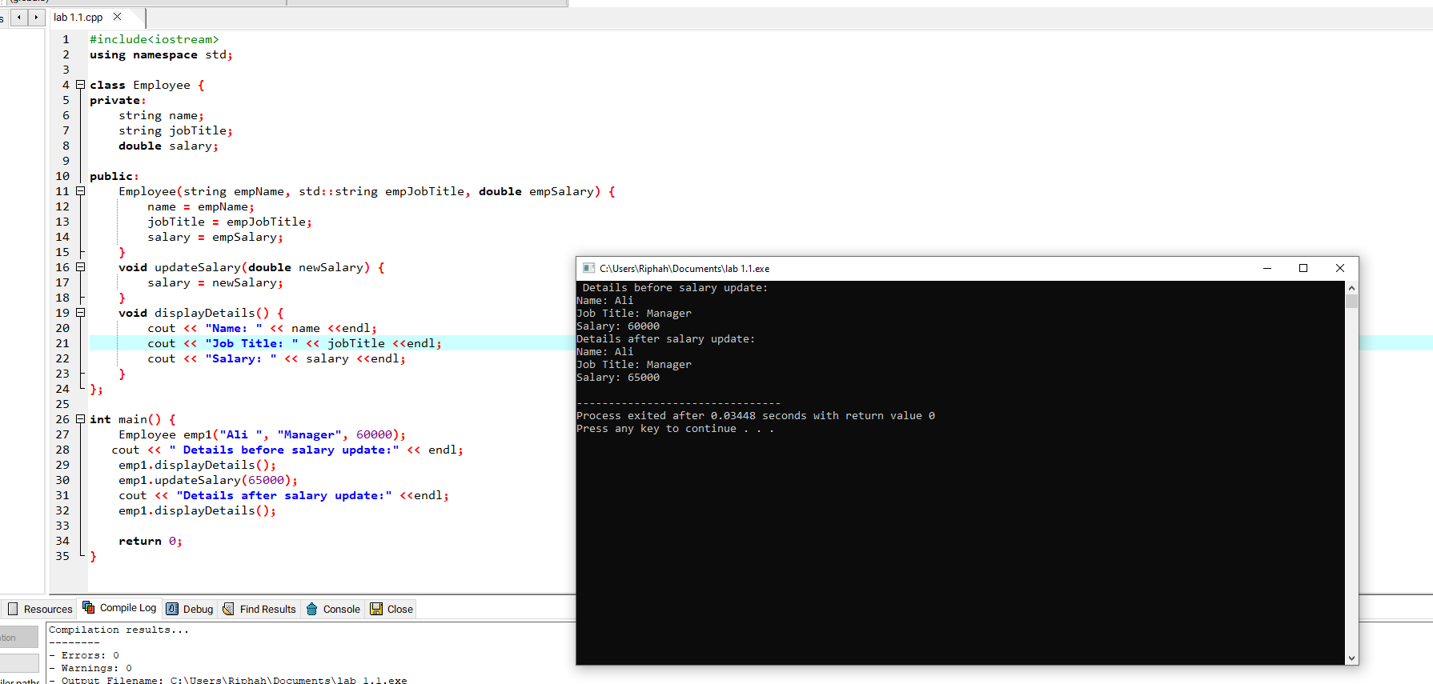

TASK 2:

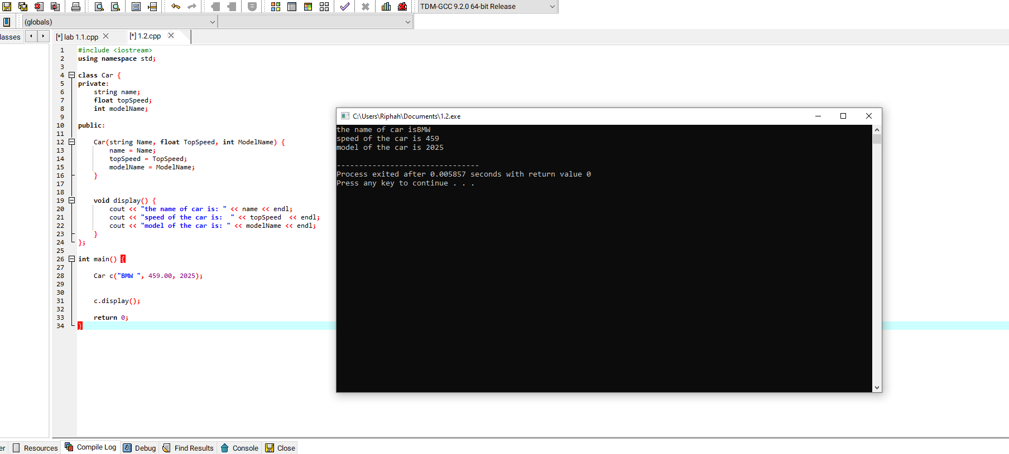

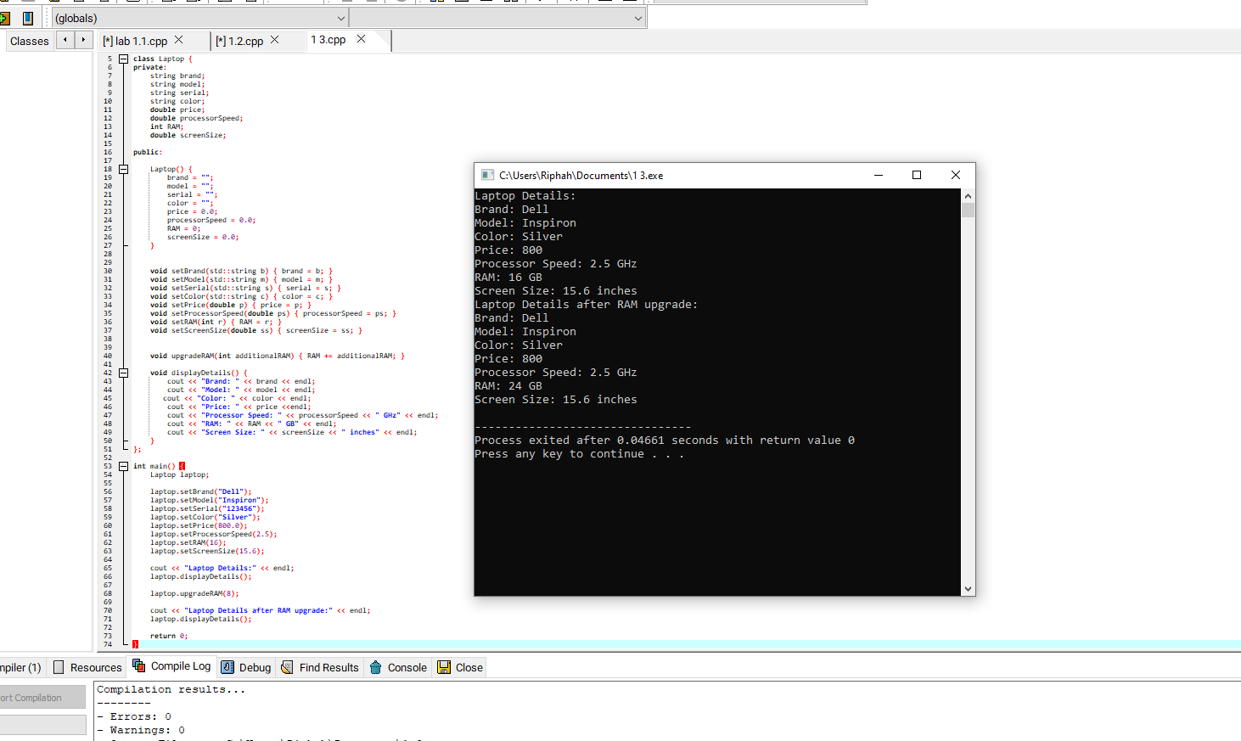TASK 3: